Lake Joondalup Environmental Impact Statement

**Introduction:** The location of this project is Lake Joondalup. Lake Joondalup is located in the Yellagonga Catchment Area, which is located ~20km north of Central Perth. There is close to 400 hectares of surface water catchment, all of which impact the park, and is linked by surface flows caused by drainage infrastructure and groundwater flows. Multiple areas, such as Lake Goollelal and Walluburnup are environments in which water from this catchment inhabits. This water is slightly alkali, keeping pH of the water between 8.2-8. In order to monitor the states of areas in these systems, researcher use invertebrates such as insects, crustaceans, etc. as indicators. The abundance and diversities of these creatures differ based on the seasonal changes, due to changes in qualities of the water (temperature, salinity, etc.).

The project I will be writing about is a proposed bridge to be built over Lake Joondalup, the purpose of which is to link Waneroo and Joondalup to make access to both areas easier. This bridge can be expected to move 52000 vehicles each day, and will be placed onto 6 pillars secured by the mud of the lake. In order for the pillars to be secured in the mud, the holes in which they will be placed must be drained of water and left to dry for a month before the pillars begin to be put in. Gardens will be put in at each end of the bridge, in order to help keep with the natural look of the lake. Bridge construction is set to take 20 months, and create significant noise pollution and vibration that will effect the lake both during construction and once in use, due to the vehicles utilising it. The bridge will be lit up by 200 floodlights during construction, and then 100 once it has been completed. The Yellagonga Regional Park is of cultural and historical importance to both aboriginal and non-aboriginal peoples. There are 7 Aboriginal Sites within the park, and 4 near to it. The lake is a habitat for many different species (including species at risk of extinction), such as a non-breeding range of Caranabys Black Cockatoo. Certain threatened Migratory birds such as Great Knot, Curlew Sandpiper, Lesser Sand Plover, etc. have been observed using Lake Joondalup as a foraging site.

**Independent Variable:** Sample Time (Years)

**Dependent Variables:** Water Qualities (Degrees Celsius, mg/L, etc.), Abundance/Diversity of Secies (per year)

**Controlled Variable:** Water being sampled (use the same amount of water from the same location), Macroinvertebrates being sampled (Same sample size of each species)

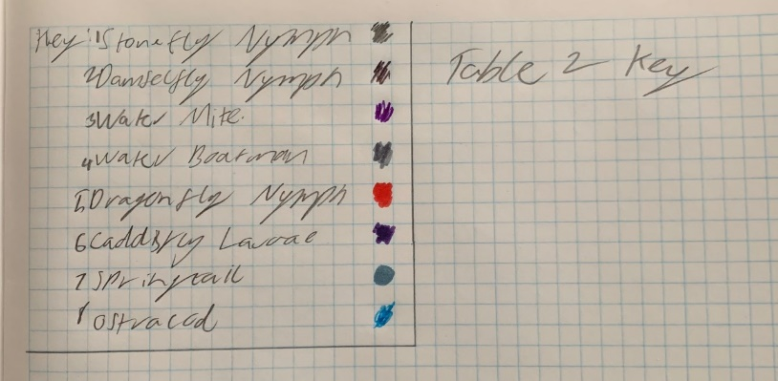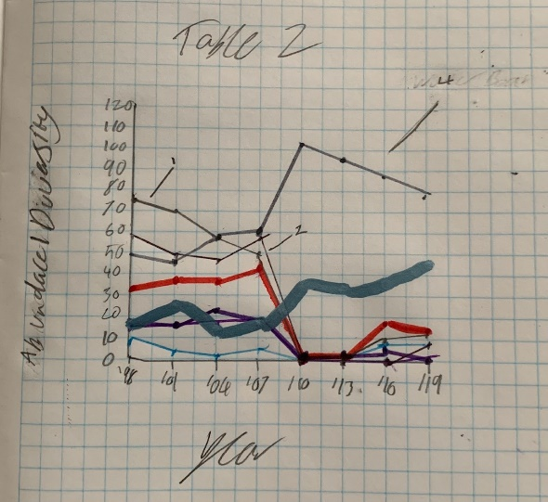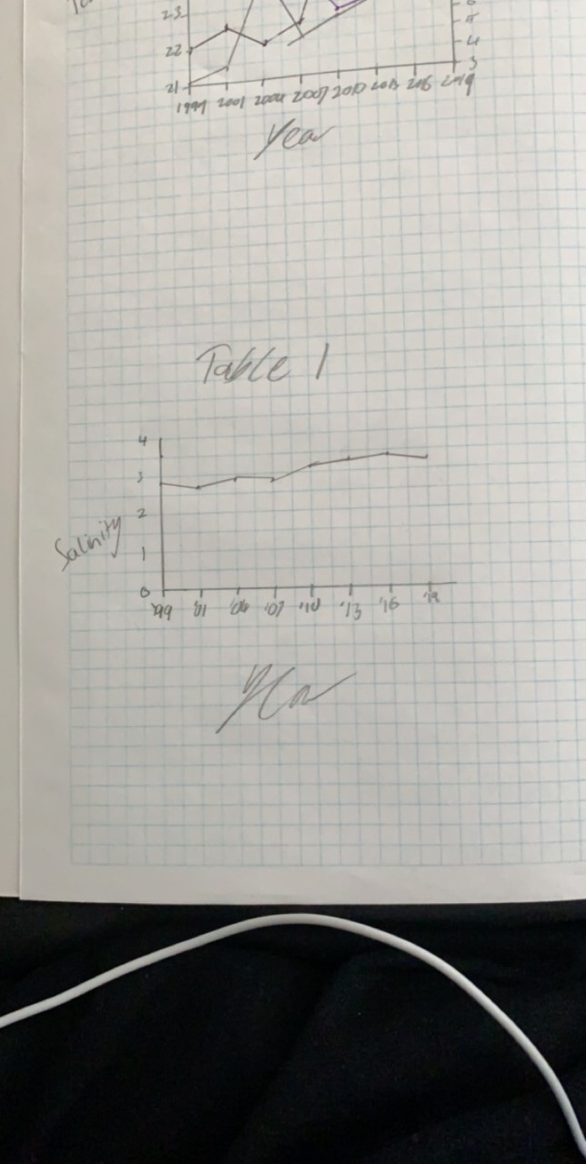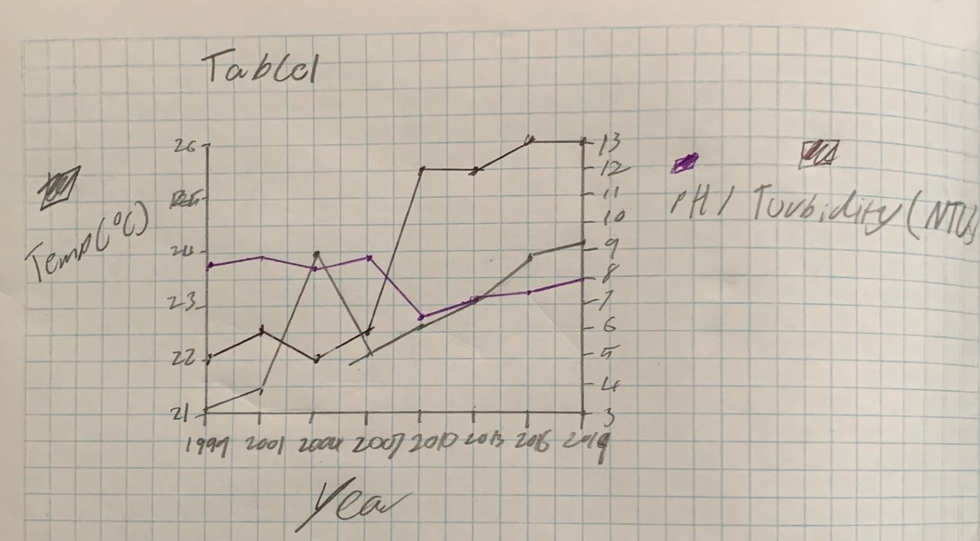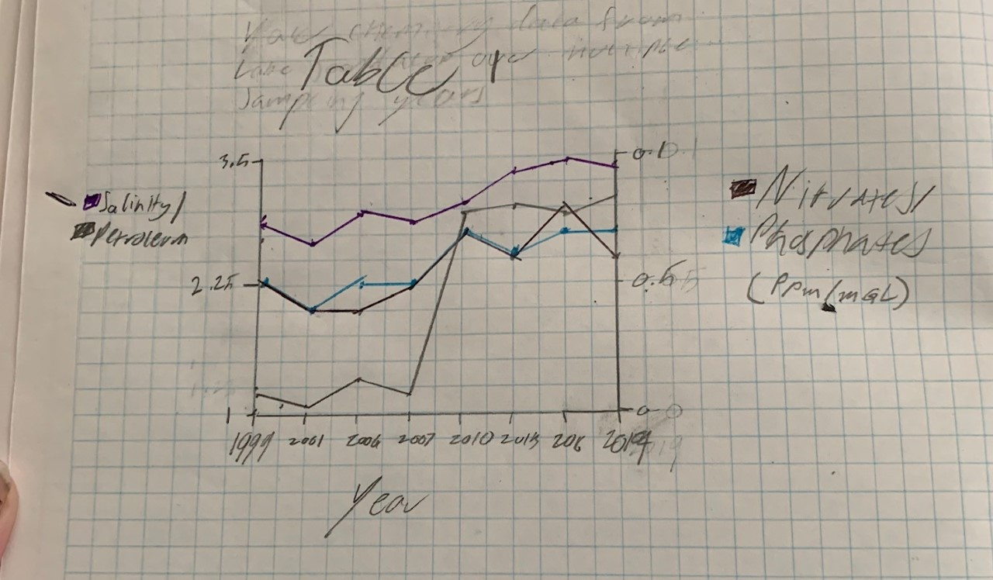**Results:**

Graph 1

**Results Cont.:** We can see potential Outliers in Petroleum (Graph 1), Turbidity (Graph 2), and Water Boatman (Graph 4)

Graph 4 Key

Graph 4

Graph 3

Graph 2

**Analysis:** In Graphs 1 & 3, we can see a trend of the recorded qualities gradually increasing, except for Petroleum (Graph 1) , which had a major spike from 2007-2010. As Turbidity had a major spike in graph 2 (2010), we see that a majority of macroinvertebrates’ abundance drops down to 0, implying a relationship between turbidity and the macroinvertebrates quality of life. The building of the bridge will heavily effect the Macroinvertebrates abundance/diversity, due to construction equipment and workers pushing them out of their homes. It will also effect water birds, by obstructing the environment in which they can fly, and most likely destroying trees and other plants, which they utilize. Fundamentally, the construction of this bridge will be positive for humans (making transport between two major areas much easier), but overall negative for the ecosystem, due to plants and land being destroyed, and animals being flushed out of their homes.

**Reliability and Validity:** This report is not overly reliable. Due to the data being take over ~20 years, it would be difficult for the test to be re run in order to boost the reliability. However, this data is significant, and as it is taken over ~20 years, it is concise and covers a broad area of time and information. The data is valid, as it was taken from the real world as opposed to an experiment in a lab, and it was taken over the course of 20 years.

**Mitigation:** Some rules that can be put in place for workers to follow could be only leaving lights on for certain amount of time (Sunset-Sunrise), in order to minimize light pollution and to minimize power expenses, and the amount of light said lights are producing, for the same reasons. The builders of the bridge could perhaps consider planning the time of construction around local wildlife migration routes/times, to disrupt the migration as little as possible.

**Limitations:** It is difficult to accurately test the entirety of Lake Joondalups water chemistry, as it is so large, so water chemistry data is only from a small sample of the water.

Data is put together in periods of 3 years, so it covers a broader and less accurate spectrum of information

**Improvements:** Choose a different area to sample water from

Collect the data annually as opposed to every three years

**Conclusion:** In conclusion, in Lake Joondalup, all qualities of water chemistry have gradually/severely risen since the beginning of sampling, and Macroinvertebrate abundance/diversity dipped in 2010-2013, and started gradually increasing from there. In my own opinion, I believe that the bridge should not be built, as it will hinder the natural progression of the lake’s biotic and abiotic factors, and civilians should be able to handle the extra commuting time so that the lake stays healthy.